**Betty Martin’s Three-Minute Game**

*as explained by Tanya*

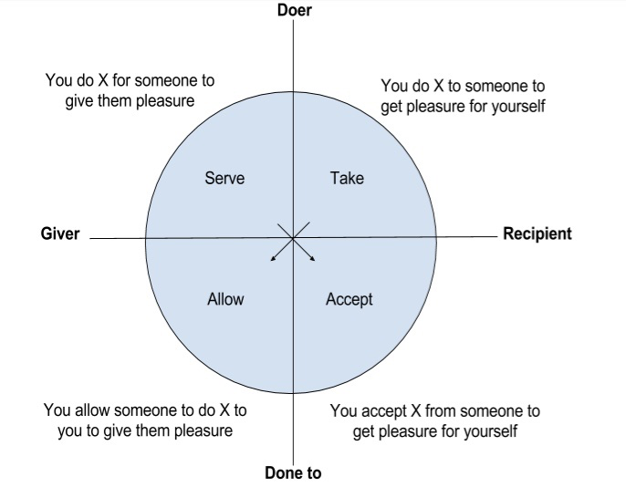

**First Set a Container**

Setting a container is deciding what is OK for this session and what is not. Every day we feel differently about contact, touch, physical connection, sex. A container allows us to work out what is right for us today, right now.

It’s only valid for this one session. Next time negotiate a new container.

Just because something is OK today, doesn’t mean it will be OK tomorrow.

Just because something isn’t OK today, doesn’t mean it won’t be OK tomorrow.

In your container for the three-minute game you can negotiate:

* how long you are going to play the game (if longer than the 20 mins Tanya asks you to)
* if you are going to play it with:
  + - clothes on
    - in underwear
    - naked
* If your touch will be:
  + - Platonic – for pleasure
    - Erotic
    - Genital / in underwear zones
* What parts of your body you do not want to be touched
* Any other boundaries you may have

Once this has been set you can start the game.

**Playing the Game**

Start out first by asking your partner for three minutes of the type of touch you would like to receive. This touch is for you. Feel into your body for at least 20 seconds. If you don’t know, take your time. It will come to you. Take as long as you need.

When a request for touch is made, the person hearing the request says:

“Thank you – I would love to do that “

OR

“Thank you – is there anything else you could ask for?”

The person giving the touch takes responsibility for their limits/boundaries.

When that touch has been given. Swap roles and the giver now becomes the receiver.

Do this so that you have at least three turns each. Remember to spend a minimum of 20 seconds feeling into your body before making any requests for touch.

After you have played the game this way a number of times (6-10) then you can add in requests for touch that you would like to give to your partner. e.g. May I touch your hair, May I give you a spanking.

Your partner will feel into the request and say:

“Thank you – I would love you to do that”

OR

“Thank you – is there anything else you could ask for?”

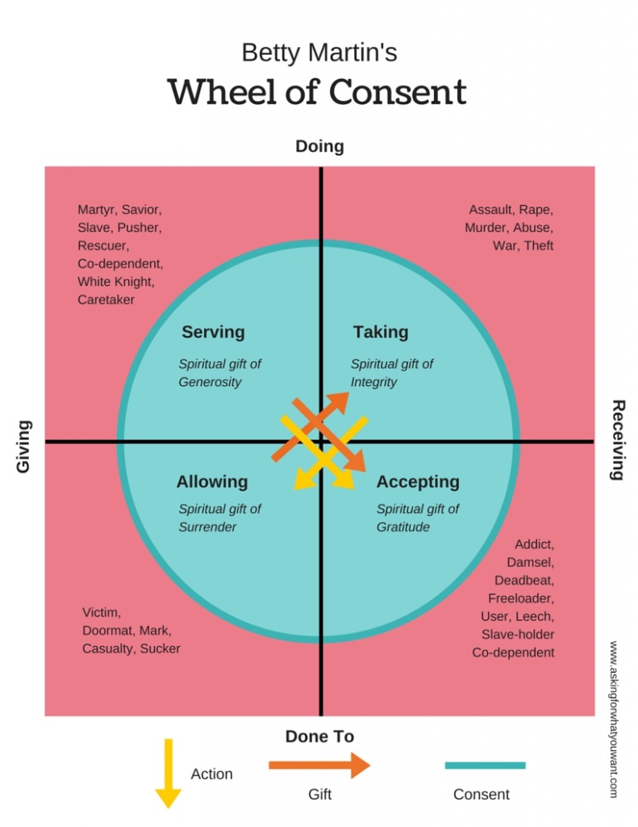

Blue = inside of consent

Pink = shadows