XOXO by April Bower Supply list

Student Level: all
need some hand strength
Materials:
24 g copper Sheet 6.5"x 2.5" (minimum) 3 to 4” width is better.
24 g fine silver sheet 6.5"x 3" for bracelet
Needed tools :
anvil/ bench block, larger is better
torch & fuel for annealing
wood forming pocket & clamps
vise
Aluminum vise jaw covers or bending block
Metal shears
File & sanding stick for edges
Flat nose pliers
Planishing hammer or very smooth metal hammer to confirm folds without much marring
Black rubber mallet and seasoned rawhide mallet
design stamps (not hammer) for texture (smaller is better)
opening tools: dull table knife, wood wedge, dull short flat screwdriver
Chasing tools Make your own (see YouTube video)
or order these:PL9 Fretz Repousse' tool
RF2 Fretz Fluting tool
PL7 Fretz planishing tool
bracelet mandrel
patina to darken the silver stamped texture like Liver of Sulfur, Gosiba, Jax, Black Max
scratch brush (optional)
flux: white paste kind for Red Heat Patina like Handy Flux
pickle, copper tongs
pro polish pad
chasing hammer for stamps & chasing tools. I prefer largest diameter face.
confirming pliers some like these: confirming pliers available in 3 sizes
Seaming Pliers 3.5" These: Seaming Pliers
safety glasses, Rag
Sharpie pen
Studio Tools
Torch.
use what you have. Bushier flame is better than small pinpoint flame for annealing.
Heat proof surface for annealing: clean fire brick or pumice tray
flux: white paste kind for Red Heat Patina like Handy Flux
patina: Your favorite blackener: Liver of Sulfur, Gosiba, Jax, Black Max for silver stamped texture
Polishing lathe or flex shaft and burs for cleanup and polishing. * 0000 steel wool and pro polish pad will do.
black silicone wheels. Are great for all around abrasive clean up with your flex shaft. Get the mandrel too as it doesn’t come with it. Flat edge shape is very useful too.
Vise

X O X O

Chased, Stamped, Silver, High Line Fold Bracelet :

Create a stunning silver bracelet packed with texture and interest. workshop by April Bower

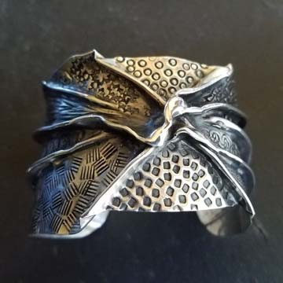
Practicing in copper or brass to learn the basics, you will quickly move on to your fine silver bracelet with high line folds, stamping, annealing, and maybe slight synclastic and anticlastic forming, & patinas 