X O X O

Chased, Stamped, Silver, High Line Fold Bracelet :

Create a stunning silver bracelet packed with texture and interest. workshop by April Bower

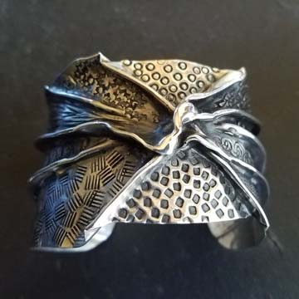
Practicing in copper or brass to learn the basics, you will quickly move on to your fine silver bracelet with high line folds, stamping, annealing, and maybe slight synclastic and anticlastic forming, & patinas 