CREATING A NEW ACCOUNT
STEP # 1
Click the Login button located in the top right of the header. The following screen appears. Enter your email address and chosen password and click the Login button.
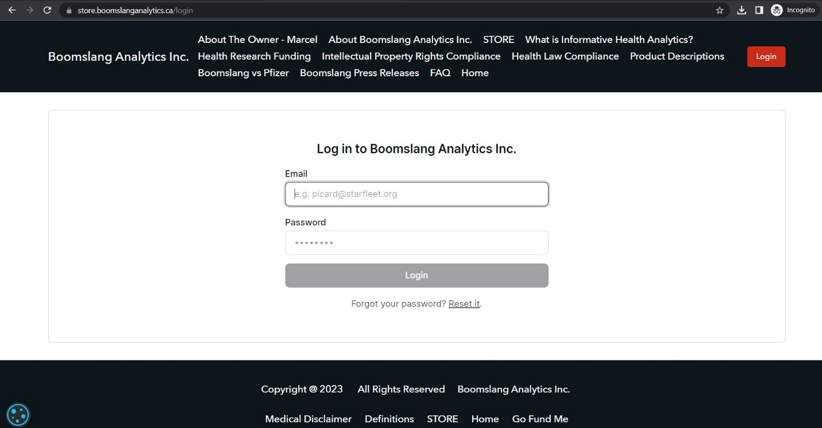
STEP # 2
The following screen appears. Enter your name (or leave it as your email address), your email address (if not already populated), your new password that you just created, check the box (if you choose to do so) I accept to receive emails from Boomslang Analytics Inc., and check the box – (post read) I accept the Terms of Service and Privacy Policy. Click the Sign me up button.
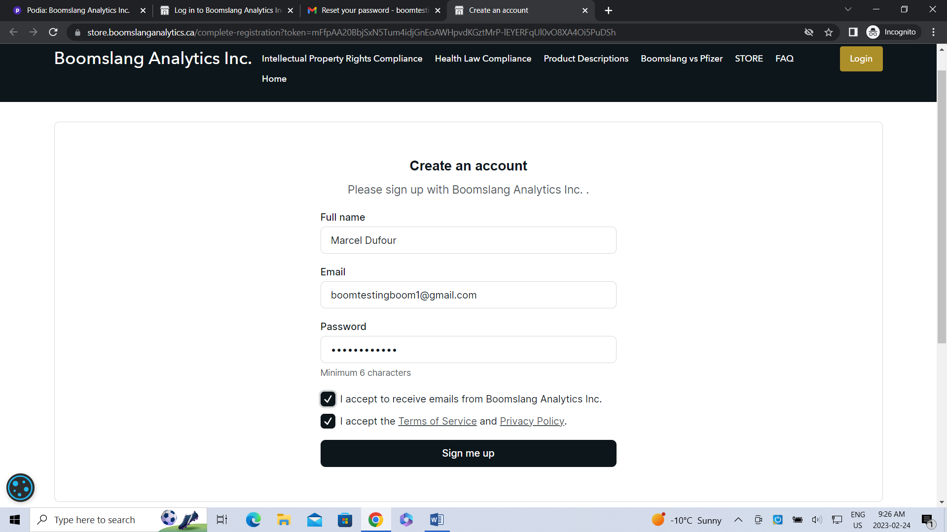
STEP # 3
The following screen appears after logging in with your email address. A message stating that a verification code was sent to your email address. Enter verification code and click verify.
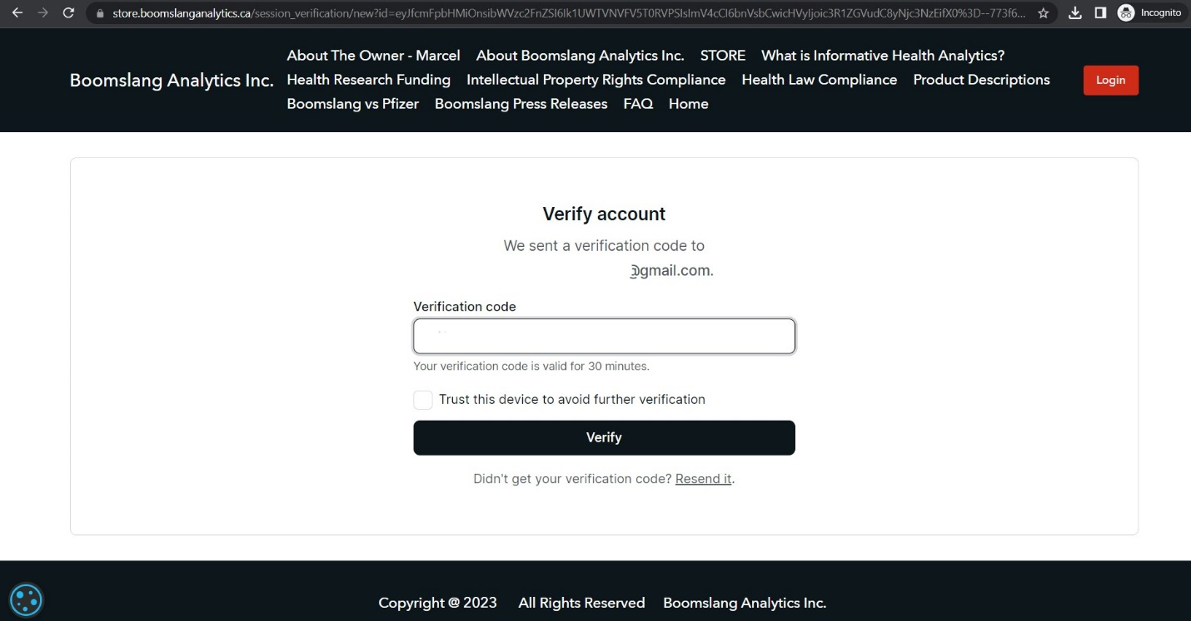
STEP 4 – Resetting Your Password
Click Reset it under the Log in button on the Login homepage. Enter email address and click Send reset email button.
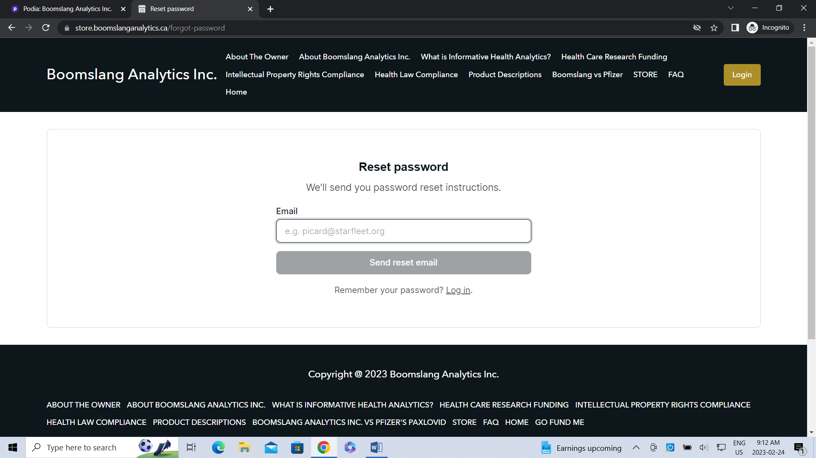
STEP 5 – Email Receipt and Set Password
You will receive an email asking to reset your password. Please click the Reset your password button OR scroll to the bottom of the email page and note where it states: Please set a password for your account; Click this statement.
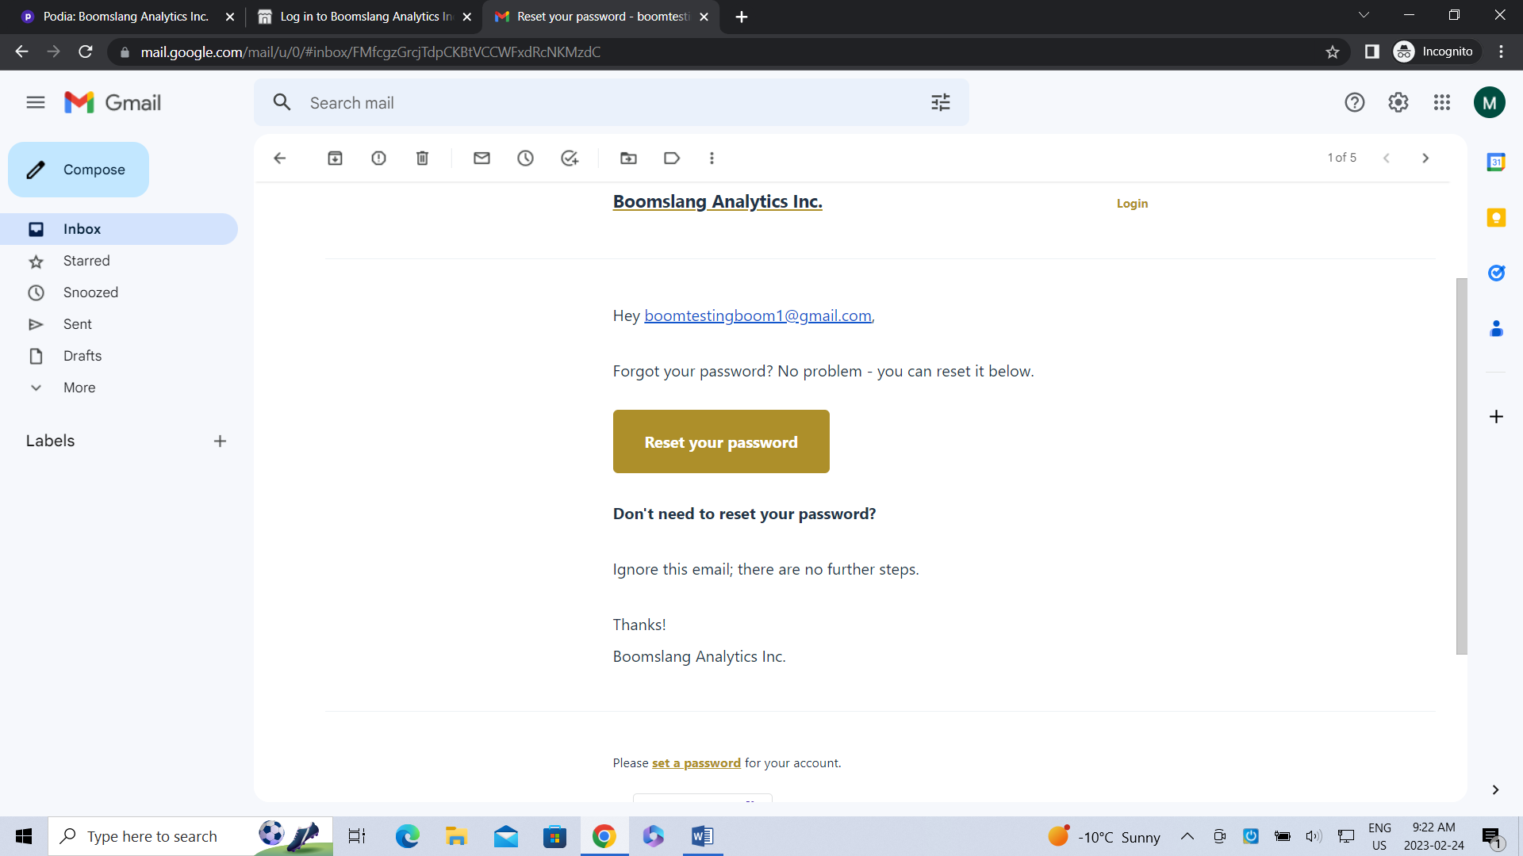
STEP 6 – Email Receipt of Account Sign Up
You will then receive an email saying thank you for signing up. A Login to your account button appears. Click the Login to your account button noted in your email and you will be transported to your account product homepage.
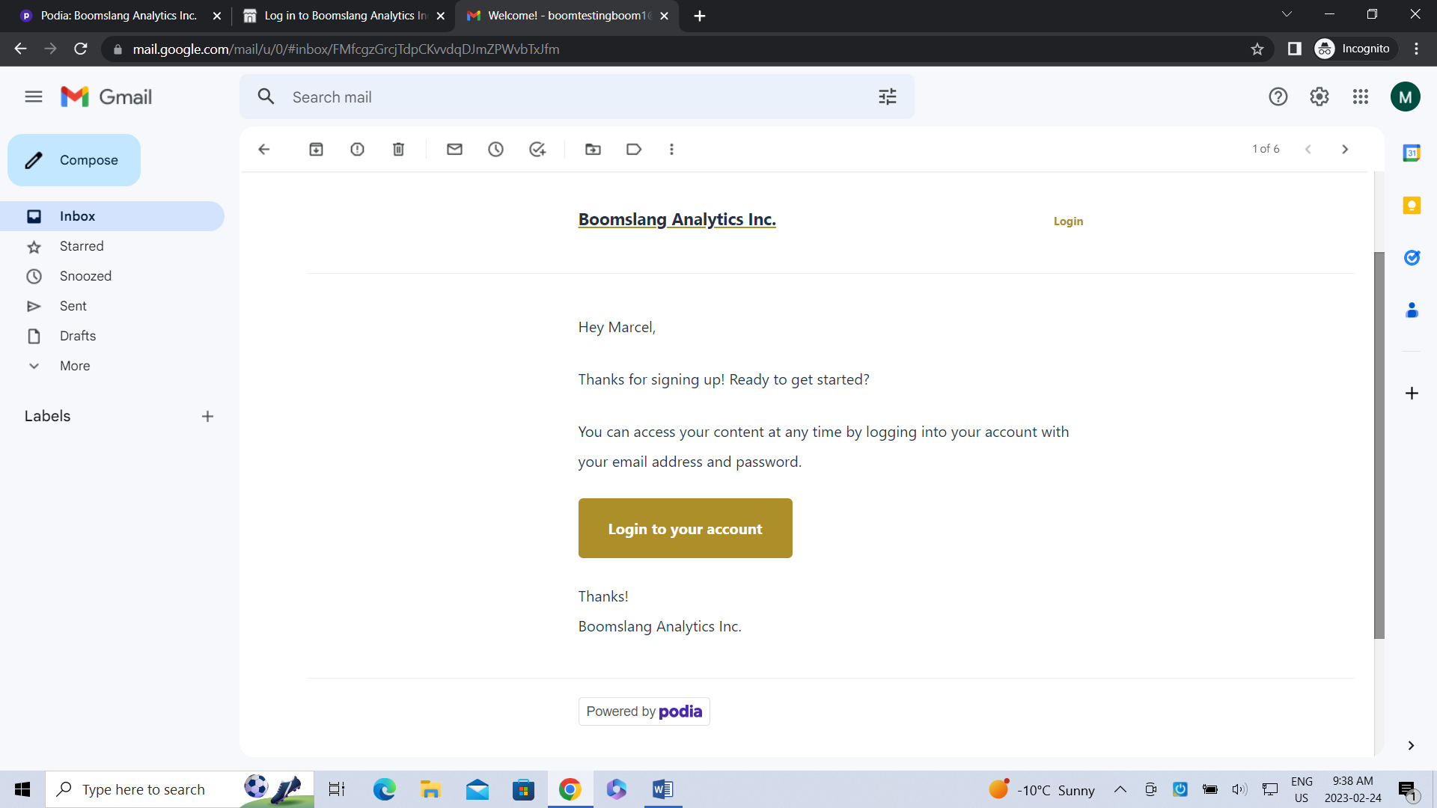

STEP 7 – Your Account Homepage
To the right, you will notice Products and MD (different initials when you Login). Products are populated with the products that you have purchased. The MD contains a drop down menu pertaining to Settings and Logout.
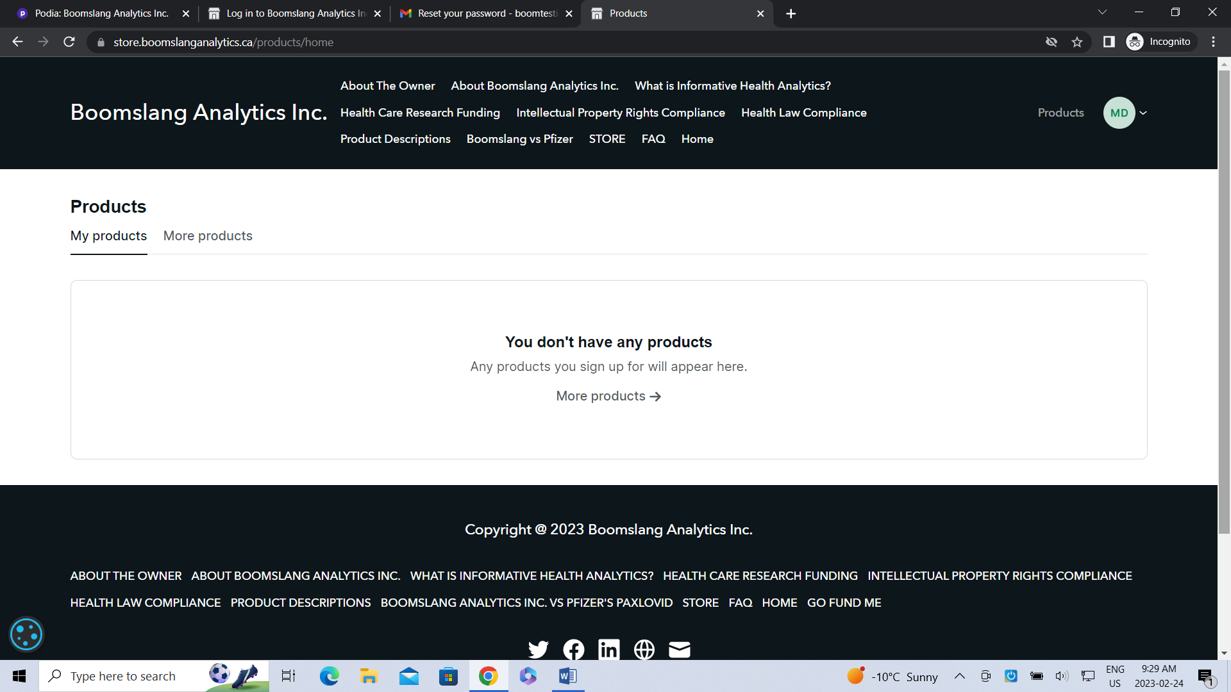
STEP 8 – Settings Page
The Account section appears first and allows for the editing of the following fields: Name, Email Address, Password, and Sessions. Delete My Account is available at the bottom of the section. The Options section lets you change photos or edit/manage notifications. The Billing section allows for the editing of your payment method if you choose to do so.
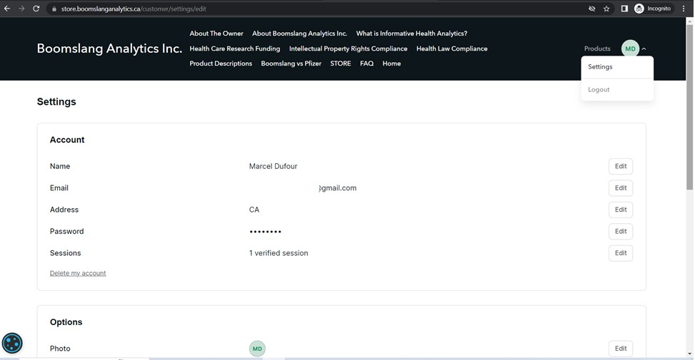
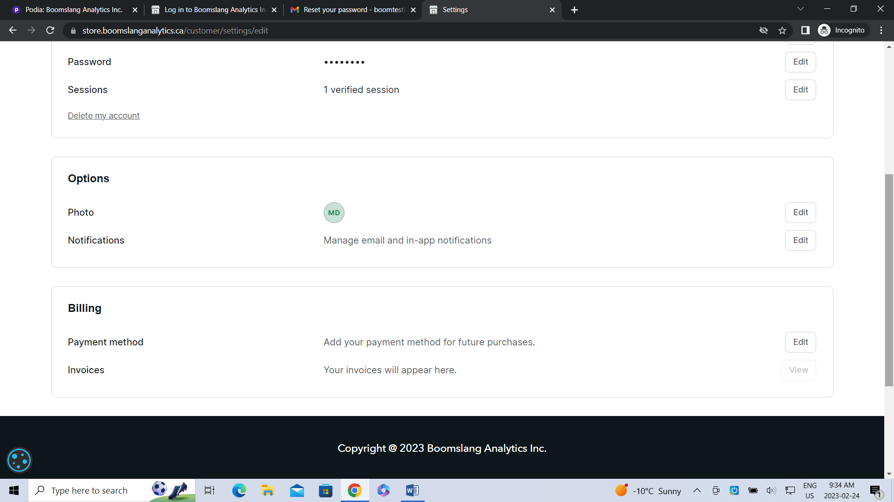
STEP 9 – Logout
Moving back up to the MD drop down menu; you may choose to Logout of your account. Simply click Logout and you will be transported back to the homepage (store.boomslanganalytics.ca).
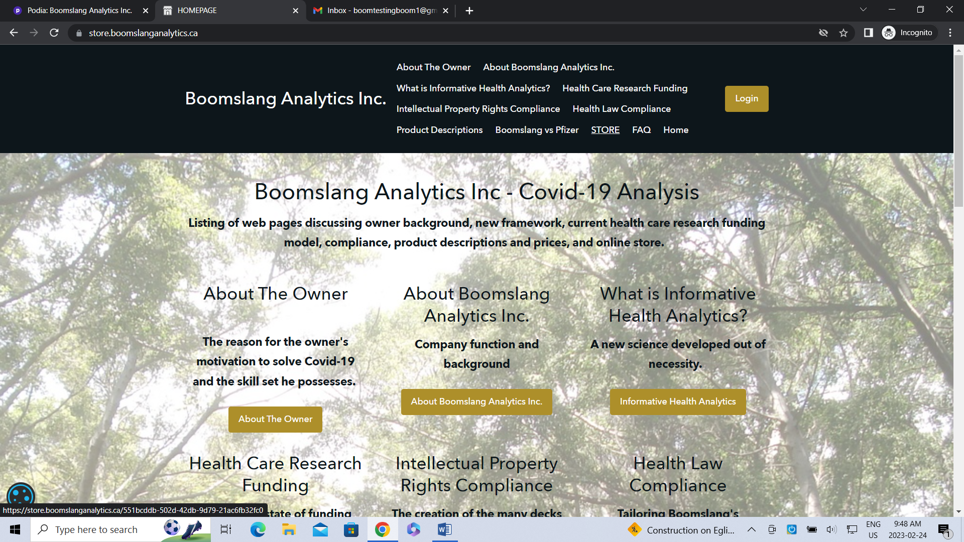

INSTRUCTIONS FOR PURCHASING DIGITAL DOWNLOADS & PRESS RELEASES (FREE)
STEP 1
Click STORE in the header OR click the red button PURCHASE DECKS HERE under the title Digital Downloads STORE.
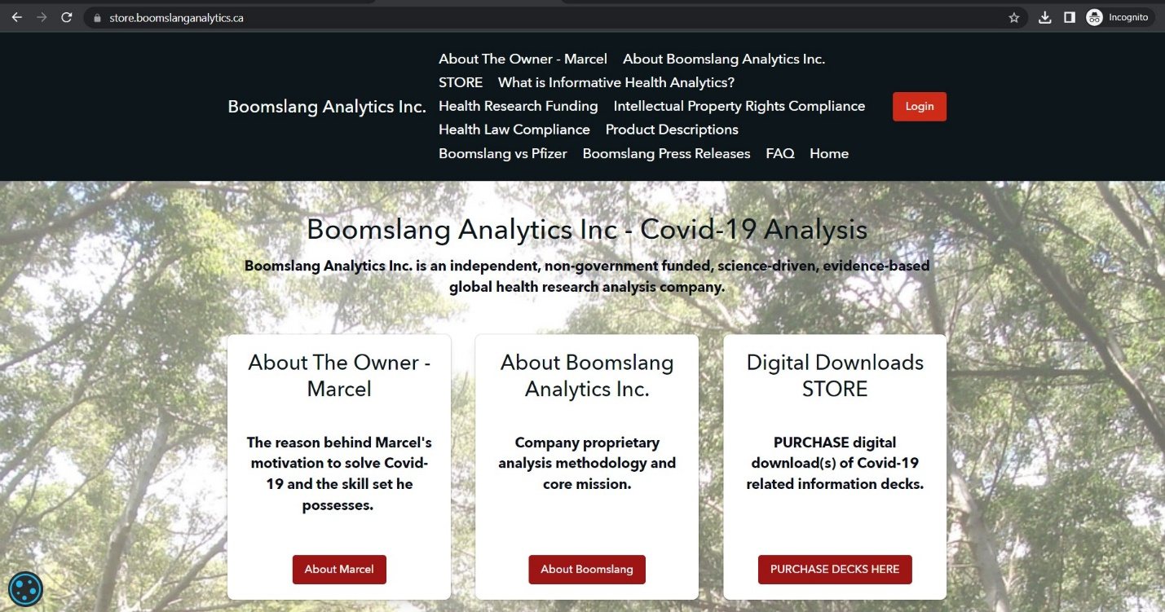
STEP 2
Choose the product you would like to purchase by clicking the appropriate Buy PDF/XLS files button. Press releases are free. Just click the FREE DOWNLOAD button.
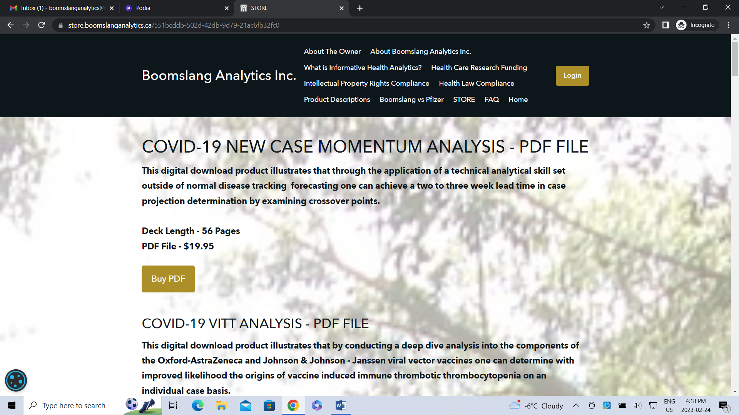
STEP 3
Click the Get/Buy now button.
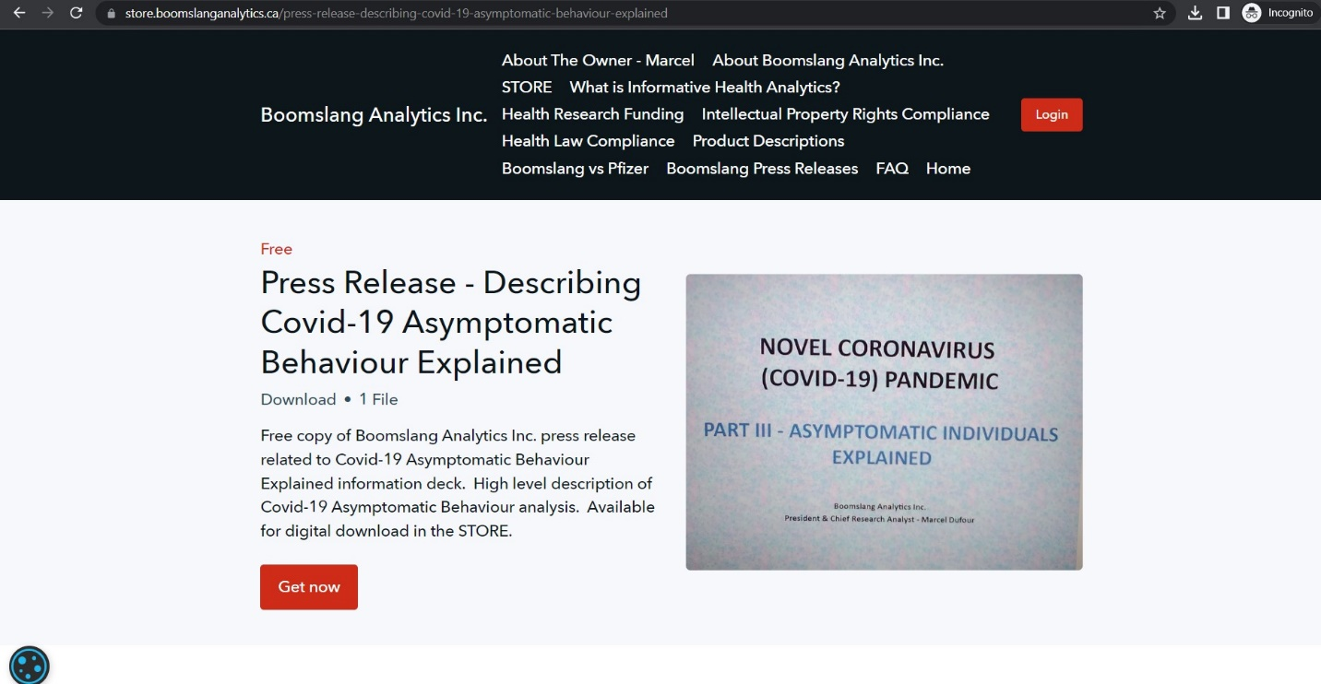
STEP 4 – Checkout
Enter your email address to login or create an account if you haven’t done so already.
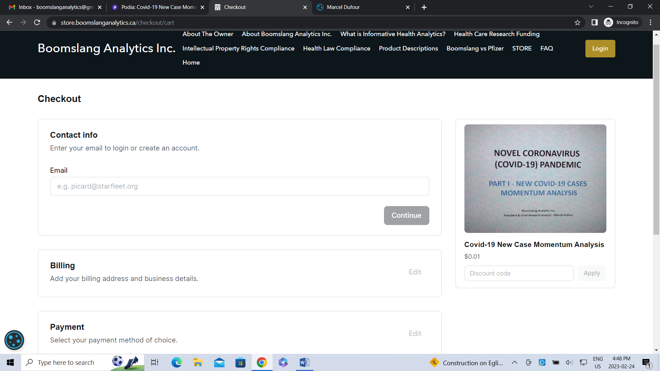

Enter billing information
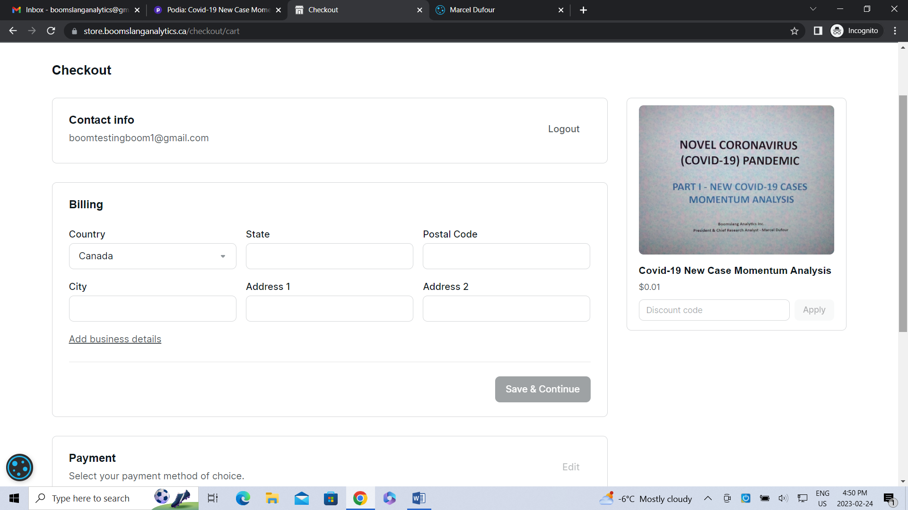
Click save and continue
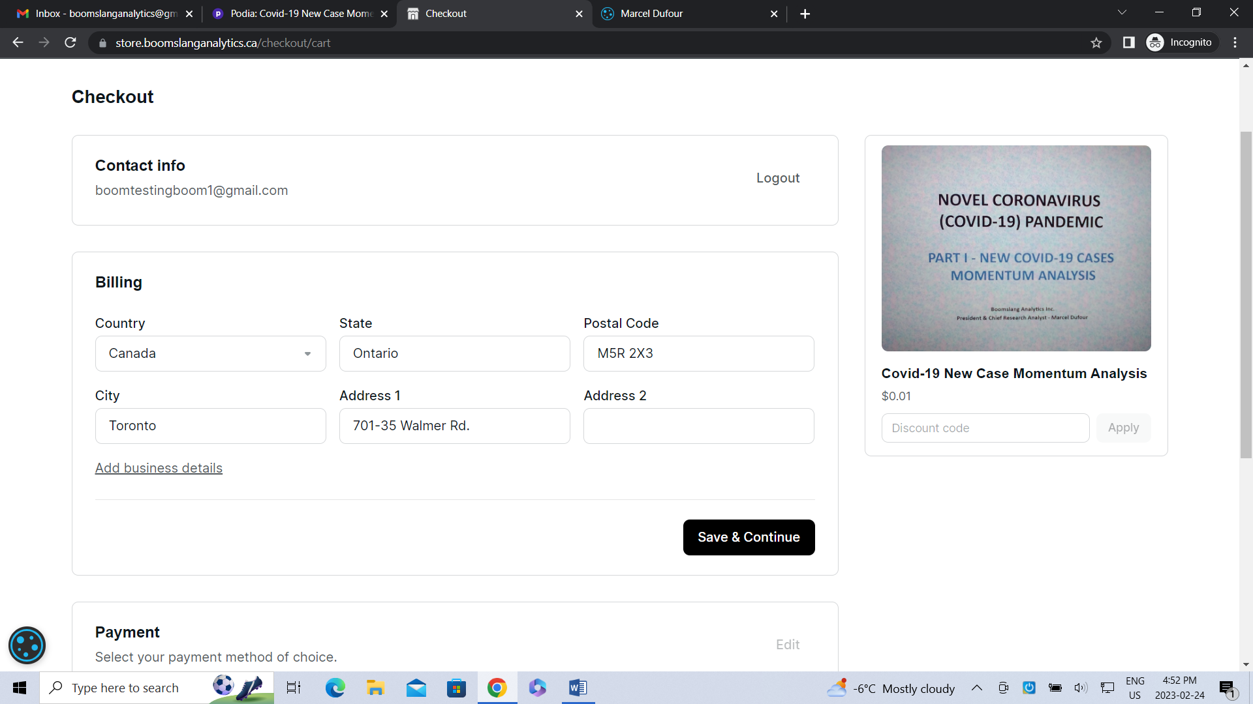

Complete Payment section
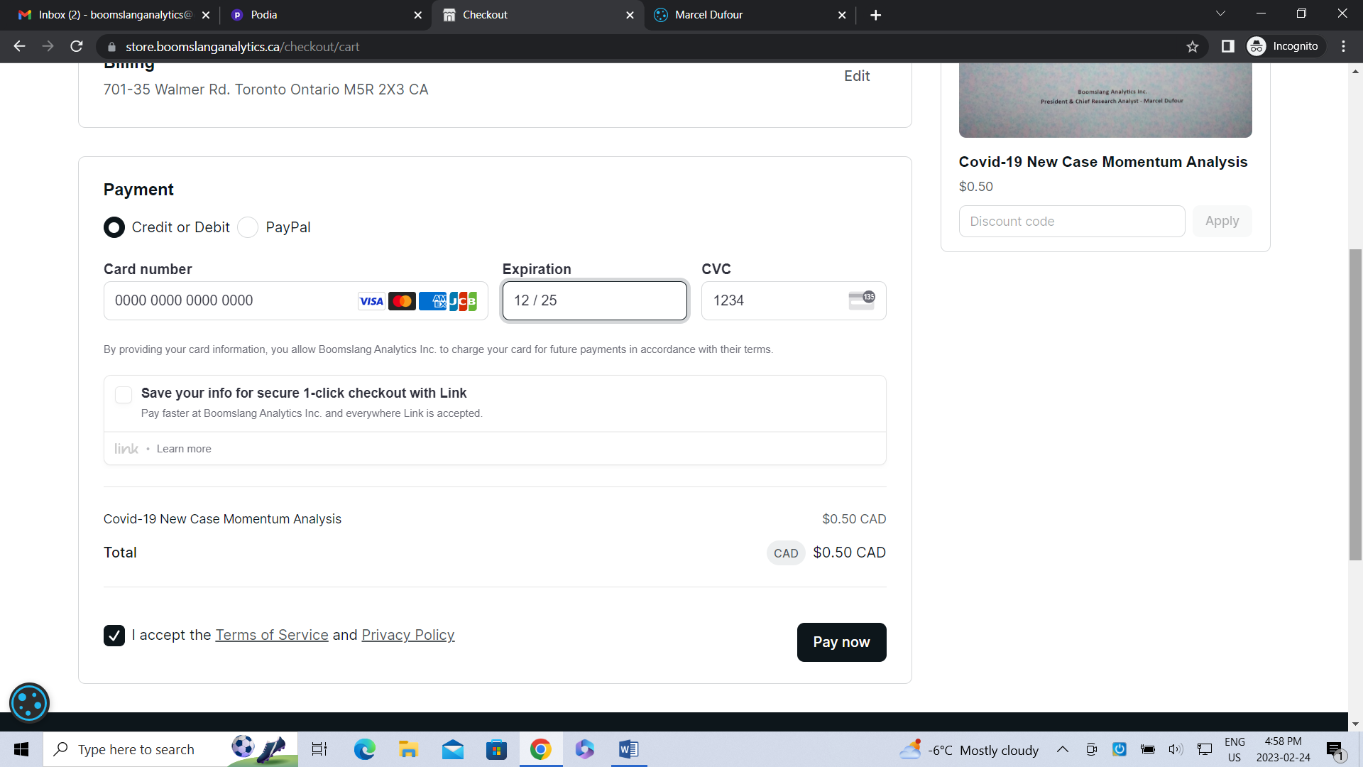

Obtain product access
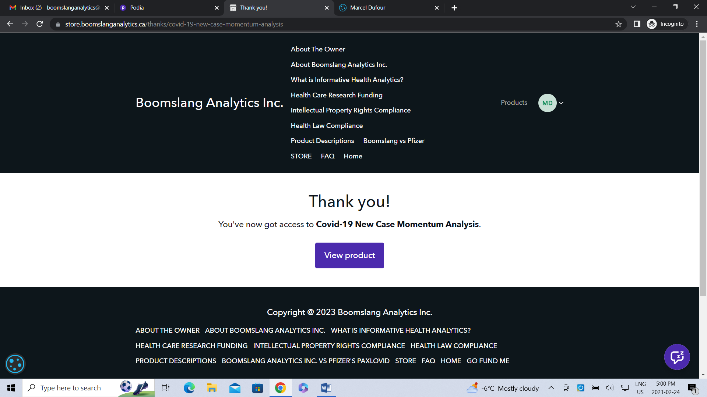

Click view product and click the PDF file or download button.
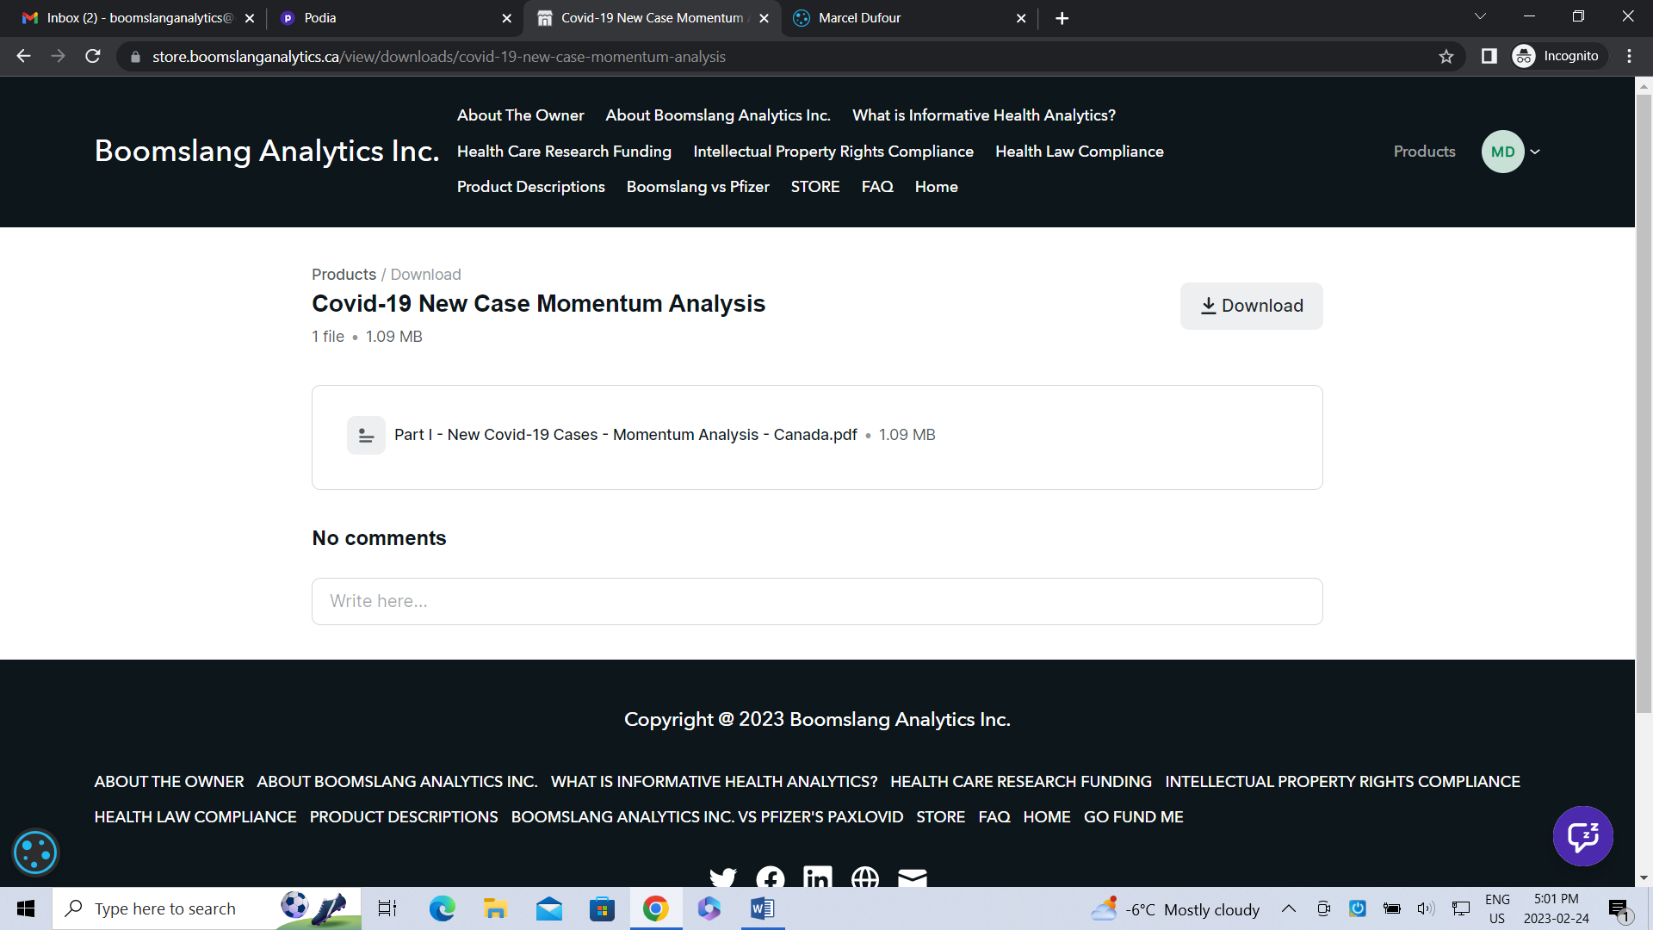

STEP 5 – Your products page
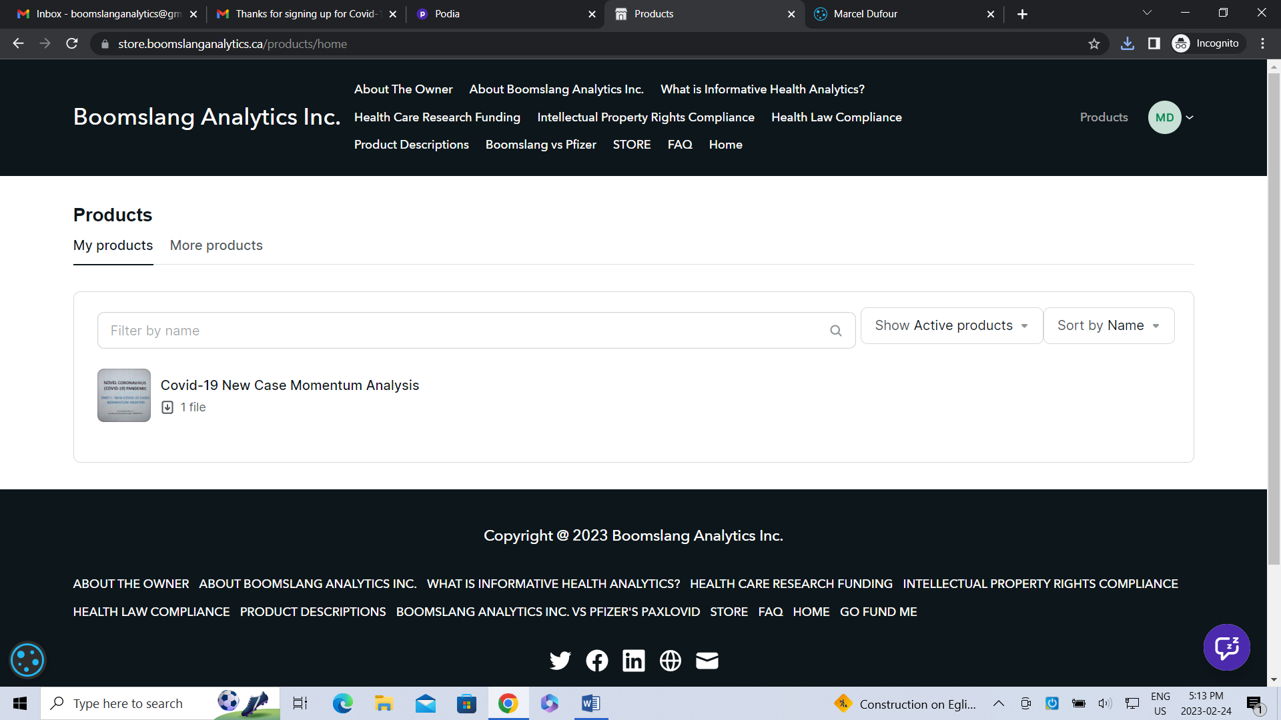

STEP 6 – Product sign up
Receive an email similar to the following:
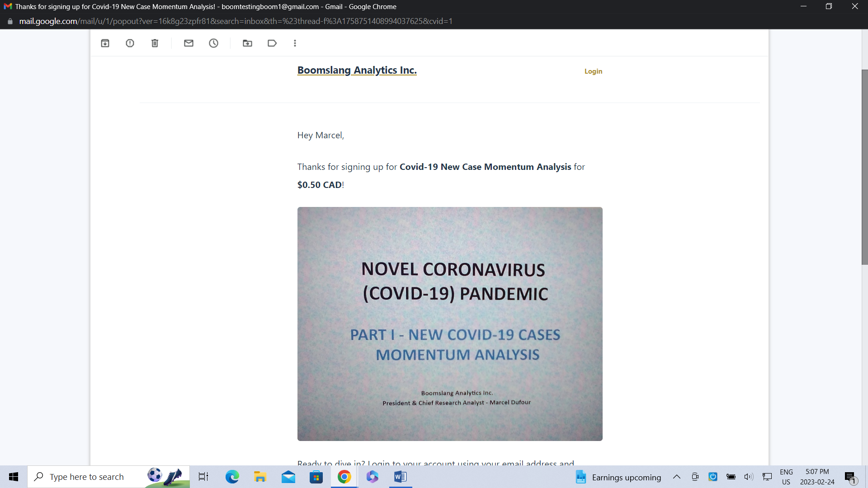

CREATING A NEW ACCOUNT AT CHECKOUT
STEP 1 – Enter email address to create account
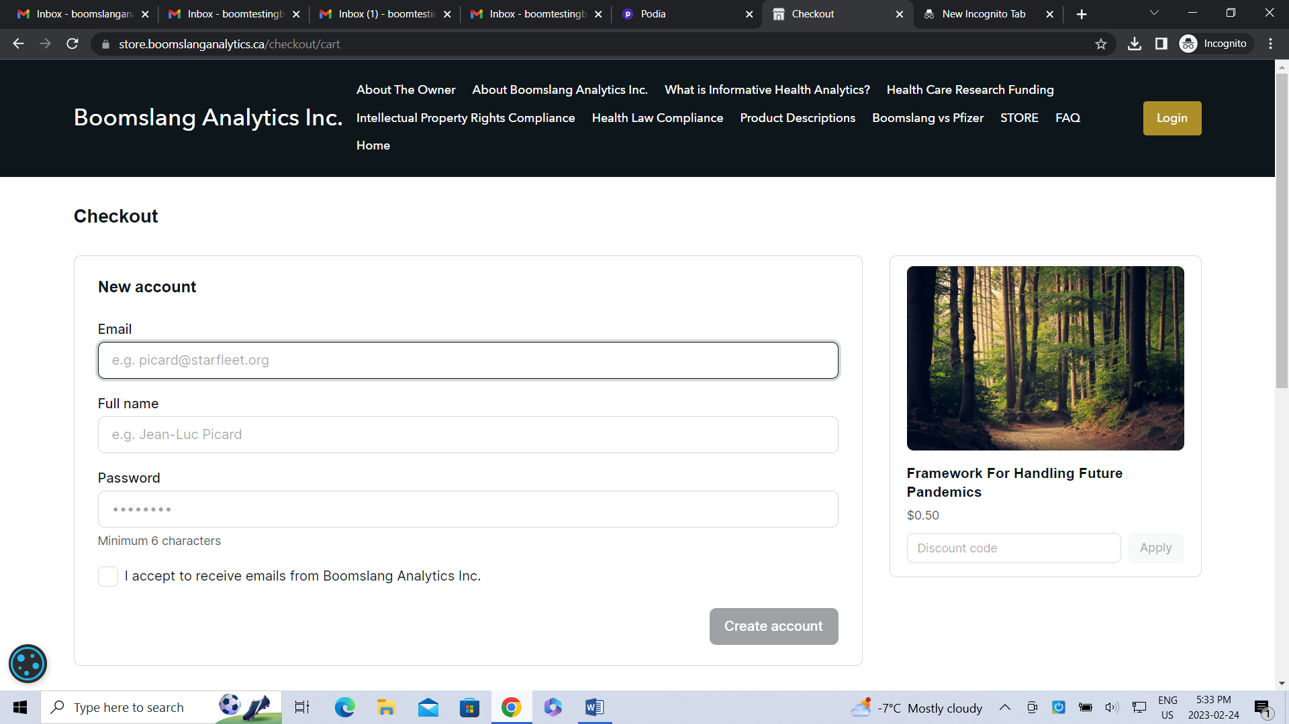

STEP 2 – Complete Step 4 Checkout as noted just above.
STEP 3 – Thank You Message
Thanks for signing up banner appears briefly at the top of the webpage.
STEP 4 – Account Login
Click the Login button noted in the Header section.
Enter your email address and click Reset it, located next to Forgot your password? (This is because you are a new customer and do not have an existing account or password).

