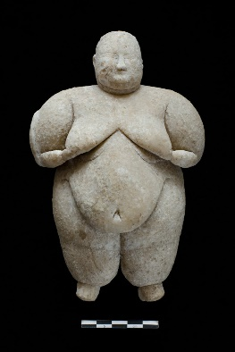
This is a group agreement for the container of All Things Mother & The Mother Codes so we can collectively contribute to creating a respectful and contained space for the duration of our journey together.
By registering you are agreeing to honour these agreements:
- I am making an intimate commitment to myself by registering for All Things Mother & The Mother Codes journey with Coco Oya Cienna-Rey
- I understand I shall receive from the Program what I put into it and take responsibility for my experience.
- I am dedicated to my self-care on this Program and I am self-resourced with the ability to find supplementary outside support if it is needed. I am responsible for asking for what I need.
- I understand I shall be part of a group experience, where we share our journey together and thus, I will respect the intimacy of this container. I will not publicly share what is discussed in live, recorded or written form within this private forum.
- I understand that this program has the potential of awakening and deepening aspects of myself previously unknown when I participate during a live call, pre-recorded call or within the Facebook group space.
- I understand Coco Oya is not a therapist; she is a Guide during this journey and I am aware that each journey may be activating and by taking part I agree to hold myself through what arises or ask for guidance/assistance.
- I am aware that the recordings of these sessions may be used for further teaching opportunities within this working portal of Coco’s container or across other platforms.
- I acknowledge that Coco Oya Cienna-Rey is not responsible for the effects the content may have on me, how I may interpret or use the content or what I may take as a result of having engaged with the content.

By proceeding with this program, I hereby acknowledge that I have read and understood the shared agreements and will honour them during and after the programme
Name - ___________________________________________________
Signature- _________________________________________________
Date-_____________________________________________________
(If you agree with these please sign this copy and proceed to make your purchase. If not please contact me via DM) I look forward to taking this journey with you – Love and Blessings Coco Oya x

