Yoruba Language Arts, and Culture
Lesson Note for Week 1 to 4
Name of Teacher: | Babatunde Adeyanju
Class: | Adult
Subject: | Yoruba Language Arts, and Culture
Topic | Álúfábẹ́ẹ̀tì Yoruba (Yoruba Alphabets)
Sub Topic | Kíkọ ati kíkà Álúfábẹ́ẹ̀tì Yoruba (Reading and Writing Yoruba Alphabets)
Reference Materials
Instructional Material | Zoom Call
Objectives | To teach students how to read, write and pronounce standard Yoruba Alphabet  Also to teach students to know how greet at various time of the day and on different occasions.
Instructions Objectives | At the end of this lesson, the student should be able to write, read and pronounce Yoruba  Alphabet. And to know how greet at various time of the day and on different occasions.
Lesson Contents | Step by step guide on how to write, read and pronounce Yoruba Alphabet. And to know how  greet at various time of the day and on different occasions.
Body of the topic | Lesson for Week 1 to 2  There are 25 Alphabets in Yoruba Language unlike the English Alphabets which  is 26 Alphabets.  Please note that these Yoruba alphabets can be written in capital letters and  small letters.  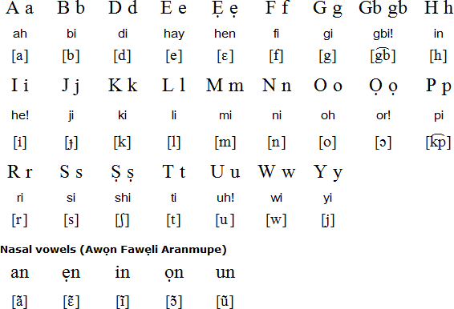  Vowels  There are also vowels in Yoruba Language just as you have in English Language.  There are 7 alphabets that make up Yoruba Vowels. They are as follows:  Consonants  Yorùbá language has eighteen consonants as found below:  Note that the English alphabets c, q, v, x, z do not exist in Yorùbá.  Lesson for Week 3  Ìkíni Ní Èdè Yòrùbá (Greetings in Yoruba Language)  When one is greeting an older person such as a father, mother, sister, brother, aunt, uncle,  and teacher or any other people that is older, one makes use of the honorific pronoun ‘Ẹ’ to  show respect. For example, to greet one’s father or mother in the morning, one will say  Ẹ káàrọ̀ o, bàbá (bàámi) or Ẹ káàrọ̀ o màmá (màámi). The parent will response  káàrọ̀ o. A girl kneels down, while a boy prostrates togreet the older ones.  Good morning! Ẹ káárọ̀! (Greeting an older person / or a group of people)  Good morning! Káárọ̀! (Greeting a younger person or play mate)  Áárọ̀ is from 12:00a.m. to 11:59a.m.  Good afternoon! Ẹ káàsán! (Greeting an older person / or a group of people)  Good afternoon! Káàsán! (Greeting a younger person or play mate)  Ọsán is from 12noon to 3:59p.m.  Good evening!(Early evening) Ẹ kú ìrọ̀lẹ́! (Greeting an older person / or a group of people)  Good evening!(Early evening) Kú ìrọ̀lẹ́! (Greeting a younger person or play mate)  Ìrọ̀lẹ́ is from 4:00p.m. to 6:59p.m.  Good evening! (Late evening) Ẹ kú alẹ́! (Greeting an older person / or a group of people)  Good evening! (Late evening) Kú alẹ́! (Greeting a younger person or play mate)  Alẹ́ is from 7:00p.m. to 11:59p.m.  Good night! Ó dàárọ̀! (This has no formal or informal way of using it. It’s a general  greeting)  Other forms of greetings:  Welcome! Ẹ kú àbọ̀ (Greeting an older person / or a group of people)  Welcome! Kú àbọ̀ (Greeting a younger person or play mate)  Ẹ kú ilé (a response to Welcome)  Ẹ kú òtútù (a greeting said when the weather is cold)  Ẹ kú ọyẹ́ (a greeting for the Harmattan Season)  Lesson for Week 4  Other forms of greetings continues:  Ẹ kú òjò a greeting for the rainy season  Ẹ kú ise a greeting said to someone working  Ẹ kú ijókòó a greeting said to someone seated  Ẹ kú isinmi a greeting said to someone resting or to someone  Ẹ kú odún a greeting said to someone during festivities  Ẹ ku ọjọ́ ìbí Happy birthday  Ẹ ku ọdún tuntun! Happy new year!  Ẹ ku ọdún kérésìmesì Merry Christmas
  B b | D d | F f | G g | GB gb | H h | J j | K k | l
  M m | N n | P p | R r | S s | Ṣ ṣ | T t | W w | Y y
  A a | E e | Ẹ ẹ | I i | O o | Ọ ọ | U u
Evaluation | At the end of 4 weeks lessons,  - the student should be a able to write a test, demonstrating that she can write,  read and pronounce Yoruba Alphabet she has learned.  - the student should be a able to write a test, demonstrating that she can write, read  - and say different forms of greeting in Yoruba language.
Questions | - How do you pronounce the following alphabets in Yoruba?  G, GB, H, I, J, Ṣ, U, W, Y,  - How will you say the following forms of greeting in Yoruba language?  Good evening!(Greeting an older person / or a group of people)  Good afternoon! (Greeting a younger person or play mate)  Welcome!  Good night!

